Pay with Bit using Tranzila API

Process description

When an end user chooses to pay with Bit, your server calls a Tranzila API service. The response contains a URL that needs to be displayed in an Iframe. The Iframe contains a QR (and a phone number to get a push notification for the payment to the customer mobile phone). When the end user completes the payment, the iframe will be redirected to a success or failure page.

Transaction request

End point: https://api.tranzila.com/v1/transaction/bit/init
Method: POST
Header parameters:
X-tranzila-api-app-key
X-tranzila-api-request-time
X-tranzila-api-nonce
X-tranzila-api-access-token
Detailed explanation regarding the authentication header parameters can be found in authentication.docx.

The transaction must be in NIS, minimum amount is 5 NIS.

Request with minimum parameters example:
{
"terminal_name": "naortest",
"success_url": "https://pay.tranzila.com/process/success",
"failure_url": "https://pay.tranzila.com/process/fail",
"txn_currency_code": "ILS",
"txn_type":"debit",
"items": [
{
"name": "Product",
"unit_price": 5,
"price_type": "G",
"vat_percent": 17
}
]
}

Complete example:
{
"terminal_name": "naortest",
"txn_currency_code": "ILS",
"txn_type":"debit",
"success_url": "https://pay.tranzila.com/process/success",
"failure_url": "https://pay.tranzila.com/process/fail",
"client":{
"company": "Naor consulting",
"name": "Naor",
"id": "0732224444",
"email": "info@interspace.net",
"address_line_1": "Yad Harutsim 19",
"address_line_2": "pob 1234",
"city": "Netanya",
"zip": "1234567"
},
"items": [
{
"code": "",
"name": "Product",
"type": "I",
"units_number": 1,
"unit_type": 1,
"unit_price": 570,
"price_type": "G",
"currency_code": "ILS",
"to_txn_currency_exchange_rate": 1,
"discount_type": "fixed",
"discount": 20,
"vat_percent": 0,
"attributes": [
{"languge": "hebrew", "name":"color", "value":"blue"},
{"languge": "english", "name": "size", "value":"S"}
]
}
],
"response_language":"english",
"created_by_user": "naor",
"created_by_system": "pay.tranzila.com",
"user_defined_fields": [
{
"name": "value 1",
"value": "value 2"
},
{
"name": "value 2",
"field": "value 3"
}
]
}

Request keys table

key | type | value | required* | remarks
terminal_name | string | yourTerminalName | R
txn_currency_code | string | ILS | R | ISO 4217 Currency Code
txn_type | string | debit | R
success_url | string | http://www.mywebsite/success | R | Redirect address for success
failure_url | string | http://www.mywebsite/failure | R | Redirect address for failure
other_installments_amount | integer |  | CR | Other installment amount for payment_plan – 8,6
client
*reference 1.1
Items  *reference 1.2 | array |  | R | The amount of the transaction is calculated from the items details. There must be at least one item.
response_language | string | english | O | english, hebrew
processor_response_language | String | english | O | english,hebrew
user_defined_fields | Object |  | CR | Key, value parameters. Keys must be identical to user defined fields in ‘My Tranzila’
*required R – required, O – optional, C – conditional, CR – conditionally required.

1.2 Client keys table

key | type | value | required* | remarks
company | string |  | o
name | string |  | o
id | string |  | o
email | string |  | O | Email address
address_line_1 | string |  | O | Address line 1
address_line_2 | string |  | O | Address line 2
city | string |  | o
zip | string |  | o

1.2 Item keys table

key | type | value | required* | remarks
code | string |  | O
name | string |  | R | Item name
type | string | I | O | I – Item  S- Shipping  C – Coupon or discount
unit_price | number |  | R
units_number | number |  | R
unit_type | number | 1 | O | 1 unit  2 gram  3 kilogram  4 ton  5 day  6 week  7 month  8 year  9 centimeter  10 meter  11 kilometer  12 MB  13 GB  14 TB  15 hour  16 litre
price_type | string | N | O | N – Net (Unit price includes does not include VAT tax)  G – Gross (Unit price includes VAT tax)
currency_code | string | ILS | O | ISO 4217 Currency Code
to_txn_currency_exchange_rate | number | 1 | O | If the currency is different than transaction currency, please send exchange rate to the transaction currency.
discount_type | string | fixed | O | Values: fixed, percent
discount | number |  | C | Discount amount.
vat_percent | integer | 17 | O | Item vat percent.
Attributes *1.2.1 | Array of objects |  | O
*required R – required, O – optional, C – conditional, CR – conditionally required.

1.2.1 Attributes keys table

key | type | value | required* | remarks
language | string |  | R
name | string |  | R
value | string |  | R

Response Example:
{
"error_code": 0,
"message": "Success",
"sale_url": "https://preprod.paymeservice.com/sale/generate/SALE1616-4195312C-TUGZGDPS-27PXPYXE"
}

Please create an iFrame using the sale URL.

Desktop
Contains QR code. In case the merchant has a definition to allow receiving the bit link to the mobile, an input for the cellular number will be displayed.
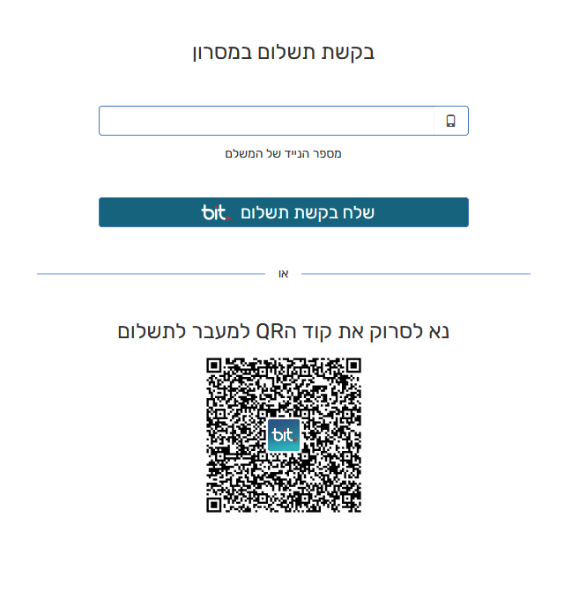

Mobile

After the customer will complete the transaction with Bit app, the page will redirect to success_url or failure_url .

